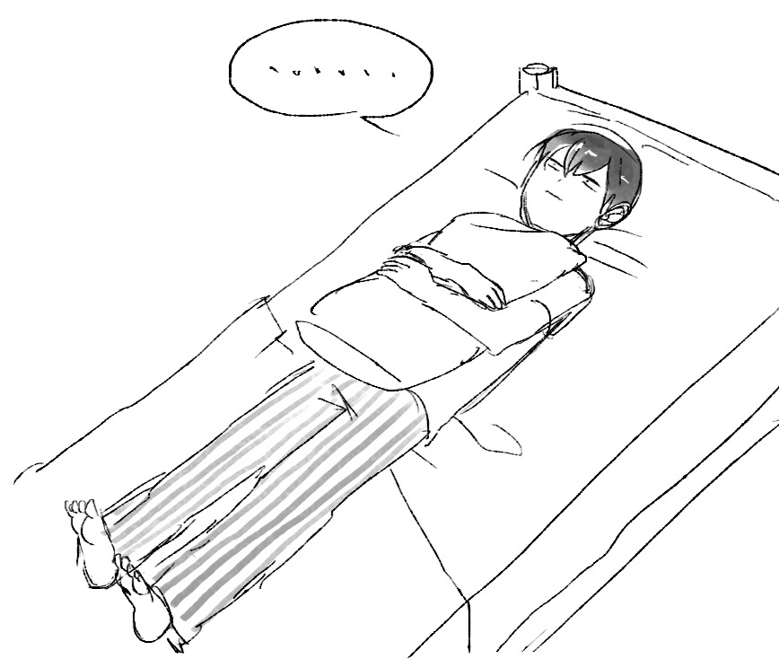
If you experience any of these for more than a week, tell an adult.
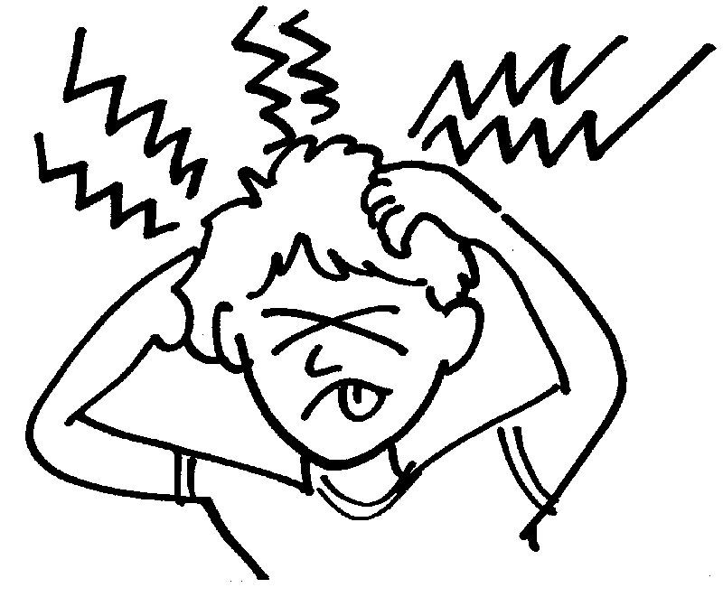
Physical: Grief can cause physical pain: headaches, stomach aches, and even muscle pain.
Sleep: People in grief may have trouble sleeping. If you can’t get to sleep or stay asleep for more than a week, tell an adult.

Sadness: Being so sad you don’t want to do things you used to like.
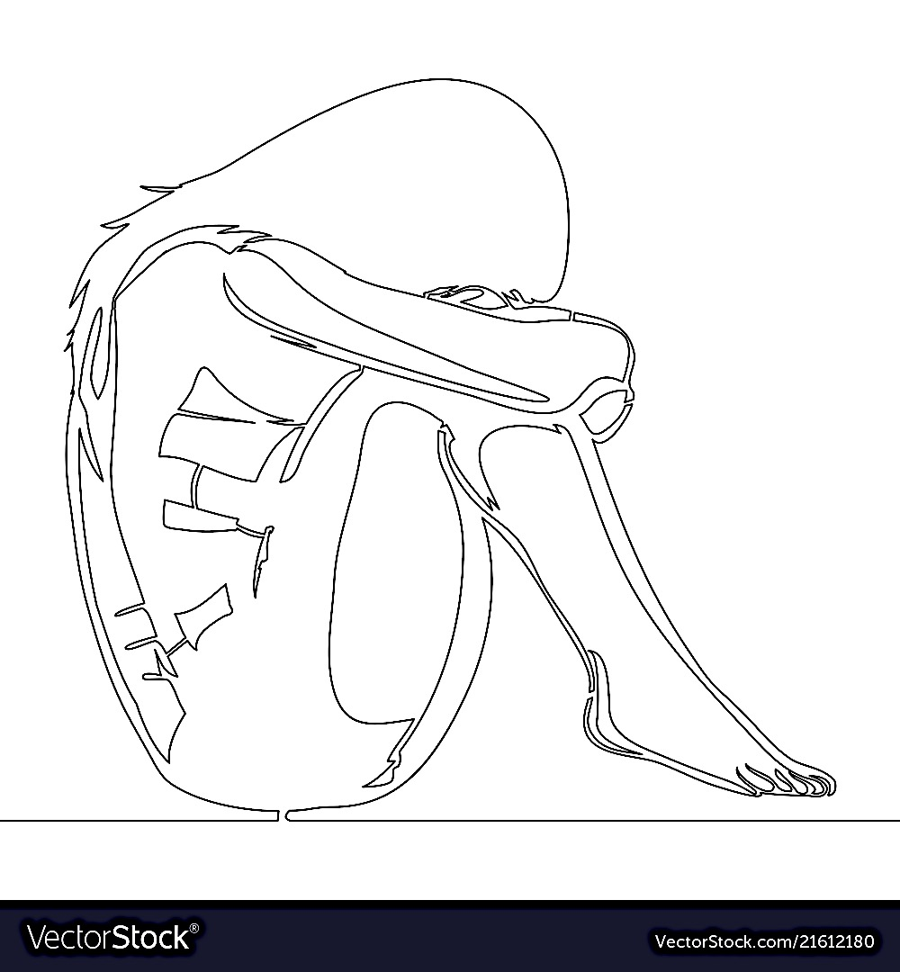
Eating: People in grief may eat a lot or not feel hungry. If you have changes in eating for more than a week, tell an adult.

Grief is like a wave.
It can come crashing down on you when you least expect it. If you are experiencing grief here are few things that might help.

- Don’t chase the waves, they will find you. It is still respectful to the person you lost to continue on with your life. You don’t need to feel sad all the time. Things will remind you of the person you lost and the wave will come crashing down on you.
- Allow yourself time to grieve and time to be OK. When those waves find you, let yourself feel the loss for a time. But, don’t stay in the wave for more than 30 minutes at a time. Your body needs rest from grief. Get up and move, do something different, or talk to a friend if you find yourself crying for more than 30 minutes.
- Plan enjoyable things to do over the next few weeks. It’s important for you to find joy in life. Make time to do the things that make you happy.
- Support your friends and family and allow them to support you. Keeping in touch with your friends and family is important during times of loss. Allow your friends to support you and check in with those you know are struggling.

Grief is like a wave. It can come crashing down on you when you least expect it. If you are experiencing grief here are few things that might help.

- Don’t chase the waves, they will find you. It is still respectful to the person you lost to continue on with your life. You don’t need to feel sad all the time. Things will remind you of the person you lost and the wave will come crashing down on you.
- Allow yourself time to grieve and time to be OK. When those waves find you, let yourself feel the loss for a time. But, don’t stay in the wave for more than 30 minutes at a time. Your body needs rest from grief. Get up and move, do something different, or talk to a friend if you find yourself crying for more than 30 minutes.
- Plan enjoyable things to do over the next few weeks. It’s important for you to find joy in life. Make time to do the things that make you happy.
- Support your friends and family and allow them to support you. Keeping in touch with your friends and family is important during times of loss. Allow your friends to support you and check in with those you know are struggling.

Life Before Loss
Loss Cycle
Life After Loss
Shock and Denial
- Avoidance
- Confusion
- Fear
- Numbness
- Defiance
- Questioning

Depression/Detachment
- Overwhelmed
- Helpless
- Tired
- Feel alone
Anger
- Frustration
- Anxiety
- Shame
- Embarrassment
Bargaining
- Tell your story
- Reach out to others
- Need to find meaning
Acceptance
- New normal
- Still feel loss but able to function

Resources
If you need someone to talk to, you can call or text 24/7 to the following:
- Text “TALK” to 38255 – A confidential help line for teens
- Colorado Crisis Services- 1-844-493-8255

