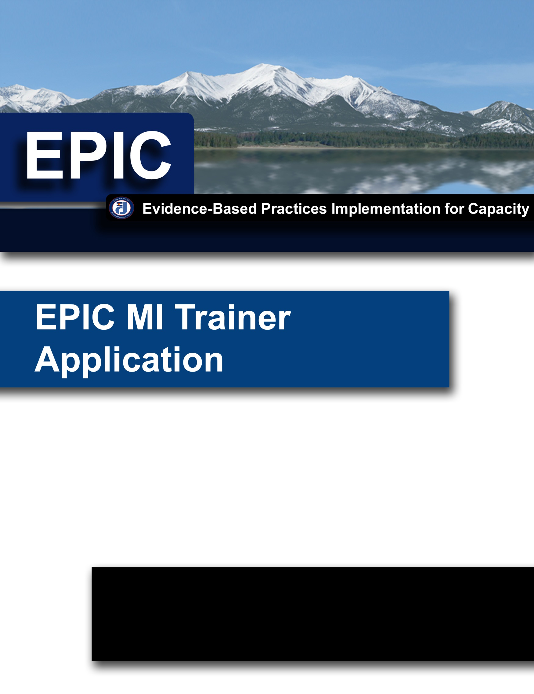
Revised December 2012

OVERVIEW

The purpose of the EPIC Motivational Interviewing (MI) Training for Trainers (T4T) is to develop quality trainers that meet high level standards in the knowledge, skills, and abilities of Motivational Interviewing (MI). These quality trainers are able to facilitate the learning of MI in a manner that maintains fidelity to the evidence-based practice.

Pre-Requisite Trainings:

- EPIC Motivational Interviewing 101(or equivalent)
- EPIC Motivational Interviewing 102 (or equivalent)

Acceptance Criteria:
- Competency in Motivational Interviewing
Prior to be being accepted to the EPIC Motivational Interviewing Training for Trainers Skill Development course, the participant must meet the following skills requirements:
    - The participant must submit an audio or video recording sample of themselves using motivational interviewing skills that is at least twenty (20) minutes in length. The sample must meet MI competency markers on each of the five (5) domains of the Motivational Interviewing Treatment Integrity 5 (MITI) in a single sample as coded by a Motivational Interviewing Tape Coder who has undergone the sufficient coding training determined by the developer of the coding instrument. The sample can be comprised of several shorter interviews. MITI 5 competency measures include the following:
      - Out of all of the reflections in the conversation, at least 50% will be complex reflections
      - Out of all the questions asked in the conversation, at least 70% will be open questions
      - Motivational Interviewing adherence will be 100%
      - Out of all the reflections used and questions asked in the conversation the ratio of reflections to questions will be at least 2:1
      - The average of all global ratings will be at least 4

- Your agency has been identified to participate in the EPIC MI T4T based on the level of agency participation in MI implementation efforts

Post-T4T Requests and Recommendations:
- Please notify EPIC of the time/locations of your trainings
- Please provide copies of completed training rosters to EPIC for data tracking purposes
- Agree to allow EPIC staff to observe trainings as determined by EPIC for quality assurance
- EPIC encourages your agency to collaborate with outside agencies and include them in your trainings

EPIC MI TRAINER APPLICATION
Prior to being accepted to the EPIC Motivational Interviewing Training for Trainers course, the participant must complete and submit the EPIC MI Trainer Application. Completion and submittal of the EPIC MI Trainer Application does not guarantee acceptance into the training.

All applications will be reviewed by EPIC staff to ensure that all applicants meet the minimum qualifications for acceptance into the EPIC MI T4T.

Name:
(Last Name) (First Name) (Middle Initial)
Agency: |  |  |  |  |  |  | Email:
Work Address:
Work Phone: |  |  |  |  |  |  | Fax Number:
Job Position and/or Title:

Application Questions (Please use additional paper if necessary):

- What EPIC Trainings have you taken? (check all that apply)

Motivational Interviewing 101
Motivational Interviewing 102
Other (Please list):

- When did you begin your participation with EPIC?

Month Year

- Please describe any relevant training you have received outside of EPIC.

- Please describe any prior training experience you have had.

- Why do you want to be a Motivational Interviewing trainer?

In signing the application I am affirming that I meet the pre-requisites for the training, and that I have read and understand the requirements to become an EPIC Trained Motivational Interviewing Trainer. (Electronic Signatures Acceptable and will be considered the equivalent of an actual signature)
Applicant’s Signature |  | Date
Printed Name

Please include the Supervisor Checklist and Approval with your application
EPIC MI TRAINER APPLICATION

SUPERVISOR CHECKLIST AND APPROVAL
(To be completed by your immediate supervisor)

Administrative supports are a critical aspect in developing quality trainers that maintain fidelity to MI as well as implementing the evidence-based practice in a sustainable way. Similarly, staff selection is also a critical element in sustaining practice and resources for your agency. Having you informed and involved in the process is important. Your input and approval is extremely valuable to EPIC and the implementation team as they consider the selection process and work to support the fidelity, sustainability and implementation of MI in your agency.

According to the following scale, please rank those qualities that you feel the applicant possesses.

5 | 4 | 3 | 2 | 1
High |  | Medium |  | Low

Willingness to accept constructive comments in order to improve skills.
Comment:

Ability and willingness to work as part of a team.
Comment:

Ability to adapt to a variety of situations and circumstances.
Comment:

Ability to present information in a meaningful way.
Comments:

Ability to work with diverse groups.
Comment:

Ability to follow through with assignments in a timely manner.
Comment:

Additional Comments:

We are asking for your contact information so that we can keep you informed and updated with the progress of this application as well as the applicant as they move through the learning process to become an EPIC Motivational Interviewing Trainer.

Supervisor’s Name:
(Last Name) (First Name) (Middle Initial)
Agency: |  |  |  |  |  |  | Email:
Work Address:
Work Phone: |  |  |  |  |  |  | Fax Number:
Job Position and/or Title:

I have read the requirements to become an EPIC Motivational Interviewing Trainer and support the EPIC trainer application of (Name): . (Electronic Signatures Acceptable and will be considered the equivalent of an actual signature)

Immediate Supervisor Signature |  | Date
Manager Signature |  | Date

