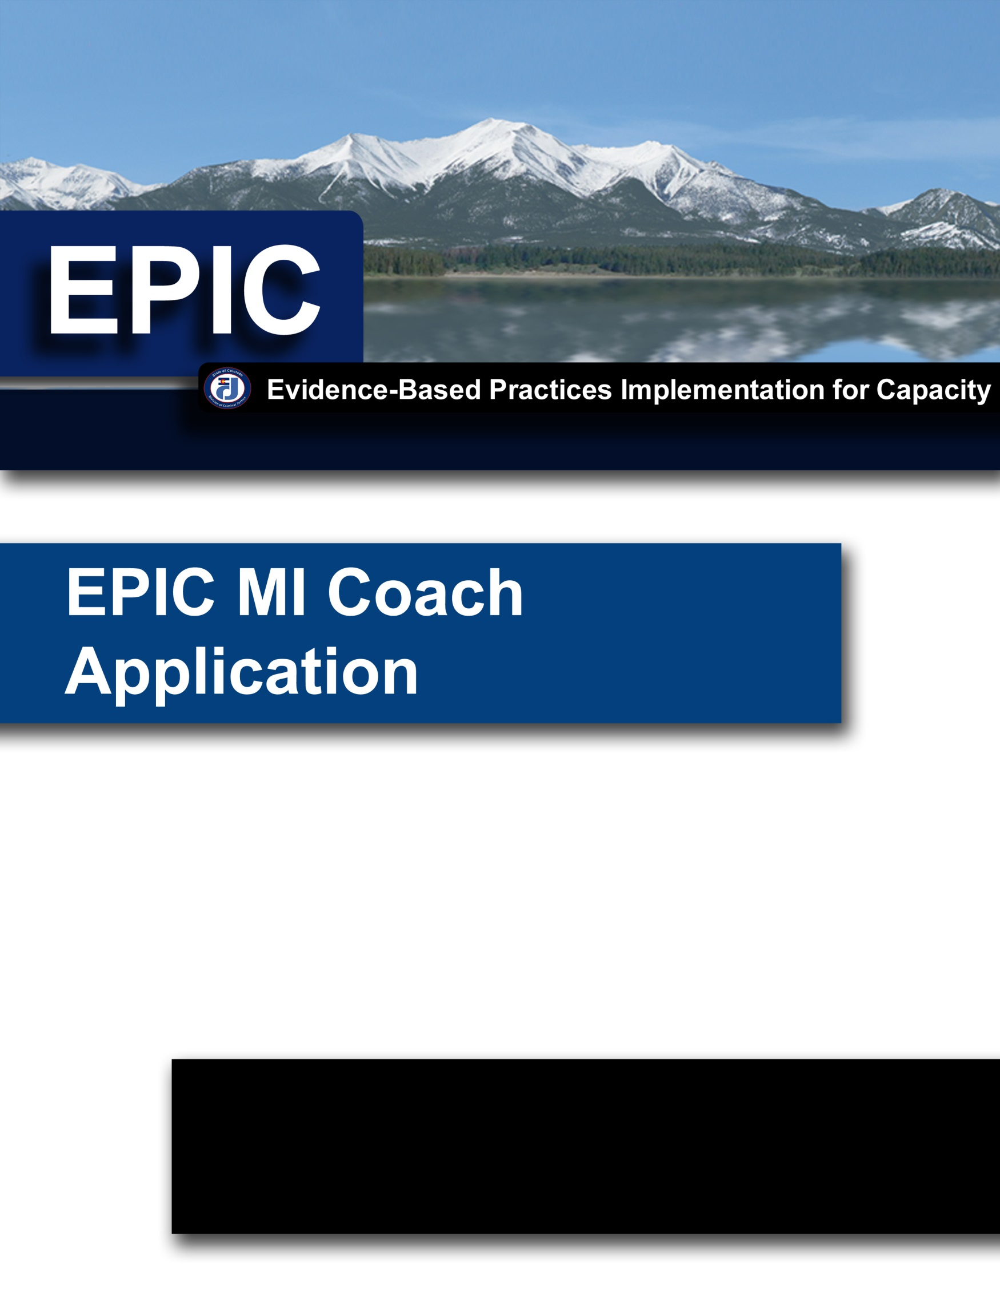

The purpose of the EPIC Motivational Interviewing (MI) Coaches Training is to develop quality coaches that meet high level standards in the knowledge, skills, and abilities of Motivational Interviewing (MI). These quality coaches are able to facilitate the learning of MI in a manner that maintains fidelity to the evidence-based practice.

Pre-Requisite Trainings:

- EPIC Motivational Interviewing 101(or equivalent)
- EPIC Motivational Interviewing 102 (or equivalent)

Acceptance Criteria:
- Competency in Motivational Interviewing
Prior to be being accepted to the EPIC Motivational Interviewing Coaches Training, the participant must meet the following skills requirements:
    - The participant must submit an audio or video recording sample of themselves using motivational interviewing skills that is at least twenty (20) minutes in length. The sample must meet MI competency markers on each of the five (5) domains of the Motivational Interviewing Treatment Integrity 5 (MITI) in a single sample as coded by a Motivational Interviewing Tape Coder who has undergone the sufficient coding training determined by the developer of the coding instrument. The sample can be comprised of several shorter interviews. MITI 5 competency measures include the following:
      - Out of all of the reflections in the conversation, at least 50% will be complex reflections
      - Out of all the questions asked in the conversation, at least 70% will be open questions
      - Motivational Interviewing adherence will be 100%
      - Out of all the reflections used and questions asked in the conversation the ratio of reflections to questions will be at least 2:1
      - The average of all global ratings will be at least 4

- Your agency has been a partner agency with EPIC in the past and is currently and active participant in the MI skill building process with EPIC (i.e., your agency is currently utilizing Change Agent taping slots with EPIC)

Post-Coaching Training Requests and Recommendations:
- Please provide documentation of coachings to EPIC if your agency
- Agree to allow EPIC staff to observe coachings as determined by EPIC for quality assurance
- EPIC encourages your agency to collaborate with outside agencies to share coaching resources

EPIC MI COACH APPLICATION
Prior to being accepted to the EPIC Motivational Interviewing Coaches Training, the participant must complete and submit the EPIC MI Coach Application. Completion and submittal of the EPIC MI Coach Application does not guarantee acceptance into the training.

All applications will be reviewed by EPIC staff to ensure that all applicants meet the minimum qualifications for acceptance into the EPIC MI Coaches Training.

Name:
(Last Name) (First Name) (Middle Initial)
Agency: |  |  |  |  |  |  | Email:
Work Address:
Work Phone: |  |  |  |  |  |  | Fax Number:
Job Position and/or Title:

Application Questions (Please use additional paper if necessary):

- What EPIC Trainings have you taken? (check all that apply)

Motivational Interviewing 101
Motivational Interviewing 102
Other (Please list):

- When did you begin your participation with EPIC?

Month Year

- Please describe any relevant evidence-based practices training you have received outside of EPIC.

- Please describe any prior coaching experience you have had.

- Why do you want to be a coach for EPIC?

In signing the application I am affirming that I meet the pre-requisites for the training, and that I have read and understand the requirements to become an EPIC Trained Motivational Interviewing Coach. (Electronic Signatures Acceptable and will be considered the equivalent of an actual signature)
Applicant’s Signature |  | Date
Printed Name

Please include the Supervisor Checklist and Approval with your application
EPIC MI COACH APPLICATION

SUPERVISOR CHECKLIST AND APPROVAL

EPIC Coaches will be representatives and resources to criminal justice professionals in the state of Colorado with expertise in evidence-based practices. Administrative supports are a critical aspect in developing quality coaches that maintain fidelity to MI as well as implementing the evidence-based practice in a sustainable way. Having you informed and involved in the process is very important. Your input and approval is extremely valuable to EPIC.

According to the following scale, please rank those qualities that you feel the applicant possesses.

5 | 4 | 3 | 2 | 1
High |  | Medium |  | Low

Willingness to accept constructive comments in order to improve skills.
Comment:

Ability and willingness to work as part of a team.
Comment:

Ability to adapt to a variety of situations and circumstances.
Comment:

Ability to present information in a meaningful way.
Comments:

Ability to work with diverse groups.
Comment:

Ability to follow through with assignments in a timely manner.
Comment:

Additional Comments:

We are asking for your contact information so that we can keep you informed and updated with the progress of this application as well as the applicant as they move through the learning process to become an EPIC Trained Motivational Interviewing Coach.

Supervisor’s Name:
(Last Name) (First Name) (Middle Initial)
Agency: |  |  |  |  |  |  | Email:
Work Address:
Work Phone: |  |  |  |  |  |  | Fax Number:
Job Position and/or Title:

I have read the requirements to become an EPIC Motivational Interviewing Coach and support the EPIC Coach application of (Name): . (Electronic Signatures Acceptable and will be considered the equivalent of an actual signature)

Immediate Supervisor Signature |  | Date
Manager Signature |  | Date

