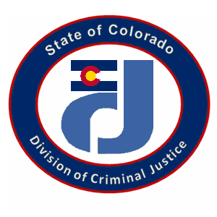
EVIDENCE-BASED PRACTICES IMPLEMENTATION FOR CAPACITY (EPIC)
Colorado Department of Public Safety (CDPS)
Division of Criminal Justice (DCJ)

700 Kipling Street
Lakewood, Colorado 80215
Phone: (303) 239-4307 Fax: (303) 239-5872
Email: CDPS_EPIC@state.co.us

REQUEST FOR EPIC SERVICES

Thank you for contacting the EPIC Resource Center. This Request outlines the services that you are requesting through a partnership with the EPIC Resource Center. Please contact EPIC via email at CDPS_EPIC@state.co.us with any questions about the Request for EPIC Services form or process.

Organization/Agency Name:
Organization/Agency Address:
^{Street}
City State
Point of Contact:
Name:
Job Position and/or Title:
Phone Number:
E-Mail:
Address:

Agency Head (if different than above):
Name:
Job Title:
Phone Number:
E-Mail:
Address:

Request for Services Questions:
Please respond to all questions.

- Briefly describe why you are requesting EPIC assistance and what services you need:
- What outcomes do you hope to see as a result of EPIC services?

- Please describe any databases, tools, processes, or resources you have in place for measuring program progress/outcomes:
- What is your desired or expected timeframe for EPIC services (include approximate start and end dates)?
- Please list any additional information that is pertinent to your request for EPIC services:

Please attach any additional or supplemental documentation (optional). Do not attach more than five (5) pages of additional documents.

By signing this Request for EPIC Services I affirm that I have agency support for this request.
Requesting Party’s Signature |  | Date
Requesting Party’s Printed Name |  | Job Title
Agency Head Signature |  | Date
Agency Head Printed Name |  | Job Title

Completed requests can be submitted online or via email, fax, or mail to the EPIC Resource Center. Please utilize the Request for EPIC Services Checklist to ensure that all parts of the request are completed and that the request is signed.

- CDPS_EPIC@state.co.us
- Fax: (303) 239-5872
- EPIC Office
700 Kipling Street
Lakewood, Colorado 80215

Next Steps:
Those seeking services will be notified via email or phone once the Request for Services has been received and again once it has been reviewed. Additional documentation to support my responses or a follow-up conversation may be needed before review of the Request for EPIC Services can be completed. Approved requests will move on to the next step in the process, which is an in-person meeting between the requesting agency’s management and EPIC staff to review in more detail the proposed work and timeframes.

