Denver C.A.R.E.S Behavioral Health Counselor Training

Please join us for the LGBT training course located at Denver C.A.R.E.S 1155 Cherokee Street Denver, CO 80204

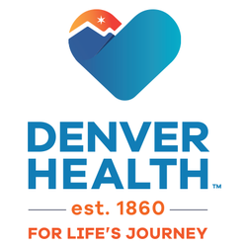
For more information, please contact the Training Department at 303-436-3570

14 Hours: Domestic Violence, Continuing Education, NBCC & NAADAC
Date: July 16-17, 2020
Cost: $140
Time: 8:00am-4:30pm
Trainer: Peter Di Leo, MA, LPC

This course will explore a range of issues which can arise in counseling Gay, Lesbian, Bisexual and Transgender clients, particularly regarding Domestic Violence interventions. Topics range from “identity and coming-out” through “homophobia and civil rights” to “life-partnerships and co-parenting.” The course will emphasize treatment planning and accessibility, and it will address rapidly growing terminologies and unique power-and-control dynamics as well as multiple assessment models, tools, and resources. Illustrative video excerpts will enhance the participant’s experience.

