Anxiety at School: A Teacher’s Guide by Mary Margaret Kerr

- How does one get an anxiety disorder?
- What does anxiety look like?
  - School avoidance or truancy
  - Lower academic performance
  - Irritability
  - Social withdrawal
  - Acting out/general disruptions
  - Inability to cope with stress or certain situations
- Prevalence of Anxiety: An estimated 31.9% of adolescents have experienced an anxiety disorder. Of those, an estimated 8.3% had severe impairment.
- Generalized Anxiety Disorder
  - worry about everyday life activities – excessive worry – especially related to school performance; Difficult to control the worrying; Worrying is unrealistic.
  - restlessness or feeling keyed up or on edge
  - being easily fatigued
  - difficulty concentrating or mind going blank
  - irritability
  - muscle tension
  - sleep disturbance (difficulty falling or staying asleep, or restless, unsatisfying sleep)
- Social Anxiety
  - Fearfulness in multiple social situations----talking, eating out, etc.
  - The individual has significant distress or impairment that interferes with daily life in social settings
  - Not being able to speak in social situations, for example.
  - This may include little or no class participation or little to no interactions with teacher/peers
  - Interrupts social skill development
- Separation Anxiety Disorder
  - Not just for young children
  - Characterized by excessive anxiety concerning leaving one’s home environment or caregiver(s)
  - Preoccupation with thinking of reunion
  - “Homesick”
  - “Clinging” behavior
    - Physical complaints: Headaches, stomachaches, nausea
- Panic Disorder
    - Marked by the presence of panic attacks
    - Persistent worry about having another panic attack
    - May be set off by “situational triggers”
    - Panic attacks appear to come from nowhere
    - Avoid situations/places panic attack may occur
    - Sweating
    - Dizziness
    - Shortness of breath
    - Increased heart rate

- Test Anxiety
  - Gap between a student’s abilities and a student’s actual performance on exams (Peleg-Popko, 2002)
  - Student is preoccupied with level of academic performance (worry, negative thoughts)
  - Cognitive
    - Uncontrollable worry/negative thoughts about academic performance
    - Constantly comparing own performance to other students
  - Physical
    - Loss of appetite/ sleep
    - Panic, difficulty concentrating
  - Emotional
    - Panic, confusion, nervousness and dread
- Obsessive Compulsive Disorder (Aureen Pinto Wagner https://kids.iocdf.org/for-kids/ocd-at-school)
Be very neat, line up, or arrange things on my desk, in my backpack, or locker
    - Check my desk, backpack, locker, or lunch bag again and again so I don’t forget something
    - Finish my work perfectly so I check it and do it again if it’s not
    - Do things over again if I get interrupted before I finish
    - Not touch things that other kids have touched, like the ball in gym, or share pencils
    - Walk through doors exactly the same way each time
    - Bump into something again or on the other side of my body to make it feel equal

- Post Traumatic Stress Disorder & Acute Stress Disorder, in brief
    - Develop symptoms after exposure to a traumatic stressor
    - Re-experience the trauma in various ways
    - Low startle tolerance
    - Flashbacks or intrusive recollections/memories of the event, nightmares
    - Repetitive play in children (relive trauma)
- What Anxiety Looks Like “On the Outside”
    - Low academic performance; academic performance gradually declining
- Student is preoccupied with talking about academic performance
- School avoidance: Students may skip school/class to avoid taking an exam or avoid social interactions
  - Frequent statements of “I can’t” or “I’m not good at this”
- Student having difficulty concentrating
    - Easily angered by changes in routine
    - High level of irritability (talking back, aggressive)
    - Behavioral disruptions
    - These behaviors may be another attempt at avoiding exams, school work, or uncomfortable situations.
    - Behaviors may include walking out of the classroom, nervous tapping of pencil, etc.
    - Physical Complaints: Stomachaches, Headaches, Nausea, Sweating, Dry mouth, Muscle tension
- What Makes Anxiety Worse?
    - Genetic predisposition
    - Adults in the student’s life set excessively high standards
    - The student must suppress his/her feelings to comply with others
    - Adults frame the world as threatening and dangerous and restrict risk-taking in children
    - Chronic stress/stressors
    - Lack of sleep
    - Life events
- The Conflict Cycle ---a model for understanding anxiety by Nicholas J. Long

- Actions to Avoid:
- Set excessively high standards
- Implement inflexible and rigid rules
- Publicly reprimand the student
- Use unpredictable grading criteria, changing deadlines, classroom protocols (example: Give “pop-quizzes”).
- Make statements like “Look who decided to come to class!”
- Enforce strict time limits during exams
- Discourage the use of relaxation techniques or strategies
- State directions once and refuse to review them
- Punish the student for behaviors he/she may not be able to control

What Works? Research has found effective ways to manage and/or lessen anxiety. These methods can be adapted for classrooms.
- Reassuring Communications: Give students safe ways to tell you about their anxiety.
- Letters
- Student info form
- “What can you tell me that will help me make learning more comfortable for you?
- On a scale of “1-5” Feedback
- Discussions
    - Give a clear message about incorrect responses in discussions
- Recognize partial answers
- Allow life-lines
- Give the anxious student the question in advance
- Allow notes
- Adopt different response formats
  - Dry-erase boards
  - Technology
- Ask for good guesses instead of answers
- Think-pair-share
- Choose answer from a list
- Location, not answer: Where would we find this answer?
- Whisper answer to teacher as she circulates around the group (elem.)
- Classroom groups
  - Allow students to work in different formats, not always in large and small groups
  - Allow students some choice about their partners in classroom activities
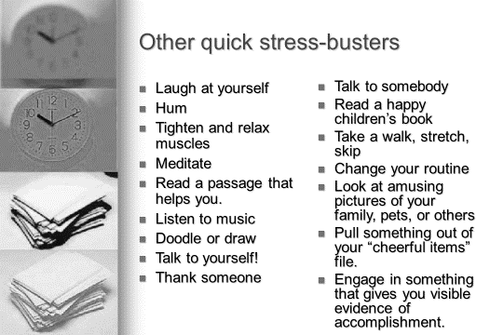
- Teach and Model Positive Coping Strategies
  - Build in 2-minute stress breaks to move or breathe
  - Let students listen to music while they work
- Academic/Test Anxiety
- Inform students of upcoming exams in advance
- Review test material with students
- Allow students to study in groups
- Allow students the use of stress balls, music, etc., during exams
- Perform a relaxation technique with the entire class prior to exams.
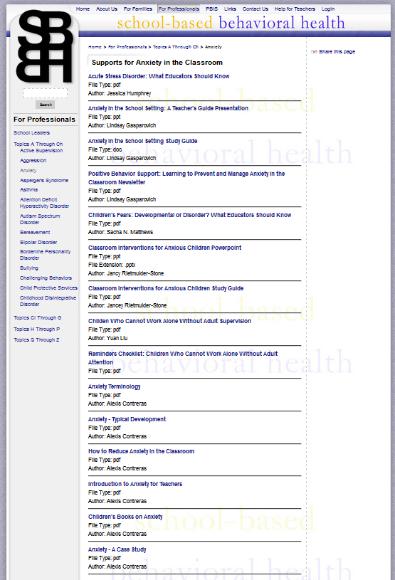
Helpful Websites:
www.sbbh.pitt.edu Professionals will find many resources on the SBBH website. Our students and faculty members have developed professional development resources including narrated slide presentations and accompanying study guides, handbooks, forms, newsletters, and podcasts with accompanying guides.
www.projectreassure.pitt.edu Created after Hurricane Katrina, this site contains resources for adults to use while caring for young victims displaced and/or distressed by traumatic events, such as natural disasters or school violence
www.adaa.org Anxiety Disorders Association of America
https://www.nimh.nih.gov/news/media/2010/joel-sherill-on-anxiety-disorders-in-children.shtml
https://www.ncbi.nlm.nih.gov/pmc/articles/PMC3018839/
National Alliance on Mental Illness: http://www.nami.org
https://kids.iocdf.org/ --OCD information.
An excerpt from the How Teachers Can Help Me: Student Self Advocacy Booklet, available at http://www.sbbh.pitt.edu/For-Professionals/9/default.aspx, which invites students to choose a few suggestions to discuss with their teachers, organized by places at school. These are examples from the section, “When I first get to class.”
_____ I might need more time getting started on my work.
_____ Help me get involved in activities that I may seem disinterested in.
_____ Ask me how my morning has been and let me go speak with my counselor if I need to.
_____ Have me sit close to the front of the classroom to keep my attention.
_____ Check to make sure I am prepared. Do I have the materials required?
_____ Greet me pleasantly. Help me get my day started off nicely.
_____ I have an extremely hard time with separations…it is one of the toughest parts of my day!
_____ Please don’t rush me to say my goodbyes!
_____ Understand that I will probably try to keep my family from leaving…offer reassurance that I will see
my loved ones again soon.
_____ Encourage me to try to have positive interactions with my peers.
_____ Greet me and tell me what to do first.
_____ Let me keep something at my desk that makes me feel better ( a picture of my family, a small stuffed
animal, etc.)
_____ Remind me what we did last time.
_____ Tell me what I will learn.
_____ Remind me of the rules and our agreed-upon consequences.
_____ Give me only a few directions at a time.
_____Post what will be happening today.
_____Let me sit next to a friend that will help me get started.
_____Give me a signal if I am doing well at the beginning of class.
_____Put a note on my desk telling me what I will need to do this morning.
_____ Clarify the rules of the class and the school (e.g., no fight, respect others, or no dangerous tools)
_____ Post the rules on walls or other place that I can easily to see them
_____ Assign routine simple work for me to help the classroom (e.g., water plants every day)
_____ Tell me what we’re doing today.
_____ Have the rules in a place where I can see them.
_____ Remind me of rewards and consequences.
_____ Give me time to get into the classroom and warm up to you
_____ Allow me to do my usual routine.
_____ Have patience with me as I may take a little longer to get situated.
_____ If you see me doing a ritual, please show me our special sign, which will remind me to stop.
_____ Remind me of class expectations
_____ Assist me with setting up my desk and area
_____ Offer me duties to occupy my time in the morning
_____ Let me know the schedule/routine for the day and tell me about any schedule changes.
_____ Have a set routine I can expect to have happen every day.
_____ Tell me the expectations, rules, and consequences so I am prepared.
_____Make sure I am not around a lot of students unless there is an adult nearby.
Anxiety: Case Studies
Case Study 1:
I can always remember feeling anxious, but I think high school is where it began to really affect me mentally, physically, and emotionally. The stress and strain I had was constant, but at night is when I would feel it the worst. There were many times when I would lie in bed scared to death. Don’t ask me what I was afraid of because I really couldn’t tell you, but I do know that I felt extremely anxious and scared. . . As my anxiety continued through high school, I set unreasonably high standards for myself. My junior year of high school, I figured I could play soccer and volleyball even though the seasons were at the same time, even preseason. During preseason I was going to soccer practice for 2 hours, then volleyball for another 4 hours and then soccer again at night for another 2 hours. Needless to say, I ran myself down. Looking back, I have no idea how I did it all. I remember having a breakdown in the middle of soccer practice. I started to cry, feeling helpless; like there was no way that I would be able to do everything I needed to do. Just like everything else, I got over it and pushed on with my life. I don’t remember telling my parents. I didn’t like telling them how I felt. I didn’t want to let them down.
Finally in college, I couldn’t take the constant feelings of anxiety anymore. It was my sophomore year of college, nearing finals week. My body had had enough. I was no longer sleeping. I would lie in bed until 4 am when I would finally fall asleep; only to wake up early for class. Even when I did sleep, I would toss and turn all night long. Needless to say, I couldn’t stay awake in classes. I was having constant headaches and stomach aches. I knew I could no longer hide what I was feeling. I finally called my parents to let them know what was going on. They were supportive, but it was obvious that they couldn’t truly understand what I was feeling. My dad came to my college the day finals were over to pick me up to take me home. Over the semester break, I ended up going to the doctor who helped me learn relaxation techniques and prescribed me medication. You would never know from the outside that I suffer from anxiety. I feel like a duck on water, my legs are going 100 mph, but on the surface I look calm and collected. I still struggle to this day with anxiety. I hope this gives you some insight about GAD and how it affected me as a young teenager and continues to this day. [Source: http://sbbh.pitt.edu/Generalized-Anxiety-Disorder/78/default.aspx]
Case Study 2:
Maria is a 13 year-old female. She is a diligent student. During tests, Maria has nausea and have sweaty palms. She complains of a stomachache and frequently leaves the classroom to use the bathroom during tests. Maria’s teachers have noticed that her grades are declining. Maria’s parents expect her to graduate high school with high grades and get admitted to a prestigious college. Maria is increasingly becoming more preoccupied with her academic performance. Maria feels she is an inferior student and that her friends who are doing better than her will think she is stupid. She fears there is nothing she can do to bring up her grades. [Source: Iska Harriott, http://sbbh.pitt.edu/2524%20Spring%202012%20School%20Leaders/HarriottIskaStuGuide042712.pdf]
Case Study 3:
Tiger pitched for his AAAA high school baseball team. His teammates and friends were unaware that he suffered from obsessive-compulsive disorder (OCD). He had a number of counting rituals that he performed before he started a game, before he picked up his bat, and before he pitched a baseball. Most of his friends had good luck rituals, too, but he knew that his compulsions were becoming unmanageable. If Tiger lost count before pitching he would feel agitated and begin his counting ritual again. His friends thought he was just superstitious. Tiger felt so uneasy at times that he missed practices. He could no longer shower at school because he had a set number of times that he had to wash each side of his body. His washing rituals took over 40 minutes.

Case Study 4:
Nikki is a 13 year old female. She has always been nothing less than an “A” student. Nikki’s parents expect her to graduate high school and college maintaining high grades.
During her last year of middle school, Nikki started to worry she would fail out of high school and never make it to college. When Nikki’s parents speak of school, she becomes irritable and back-talks to her parents. She is so worried about failing out of school that she finds it increasingly more difficult to focus and complete assignments. Her grades have started to decline. Nikki feels as if she is losing control of her life and her future academic career at the young age of 13. [Source: Lindsay Gasparovich, http://sbbh.pitt.edu/Anxiety/27/default.aspx]
Case Study 5:
Stasha was in a minor bus accident during her sophomore year. The bus hit a car parked illegally. There was a little noise, but no one was injured. We assumed that all the kids on that bus were fine. Then we got a call from Stasha’s mother. Stasha was having nightmares and even insisted on walking to school. Her mother reported that Stasha was “jumpy” every time she got into a car. When we checked with Stasha’s teacher, we discovered that she had failed her last three quizzes and seemed to be daydreaming in class.
Case Study 6:
Mrs. Song was on hall duty when she witnessed Tawnya, an outstanding student, engaging in odd behavior. Tawnya was nearly at the classroom door when she abruptly turned and walked the opposite way. A few minutes later, she appeared, coming from the other end of the corridor. When Mrs. Song asked her where she had been, Tawnya muttered something about balloons. When a few Honors Society stopped by the classroom to sell balloons for their fundraiser, Tawnya got up from her desk, walked to the back of the room, and began to stare out the window. When Mrs. Song purchased a balloon, Tawnya bolted from the room.
Case Study 7:
Ben does well on homework but rarely volunteers in class. He seems uneasy in some small group activities, and looks down when the teacher walks around to check on students’ work. He blushes when called on and sometimes stammers, even though the teacher knows he has the right answer. Yet, when the class website includes a discussion board, Ben writes lengthy posts. The discrepancy in Ben’s performance from one activity to another is puzzling.

Lindsay Gasparovich created some of this presentation as a student in Pitt’s School-based Behavioral Health Training Program with Dr. Kerr. She now serves as a clinical supervisor in a local crisis program, and generously gave permission to use her work.
Descriptions of disorders abbreviated from American Psychiatric Association (2013). Diagnostic and Statistical Manual of Mental Disorders (DSM-5®).

