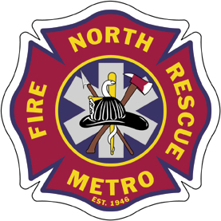

North Metro Fire Rescue District will be hosting an Instructional Methodology class on February 23rd and 24th from 0830-1630 at Training Center located at 1006 Weld County Road 11, Northglenn, CO 80516

Ned Sparks, Division Chief with Loveland Fire Rescue Authority, will be facilitating a 16-hour course on the following topics; Role of the Instructor, Safety, Legal Considerations, Psychology of Learning, Public Speaking, and Instructional Delivery, and State of Colorado Proctor class. The class meets the training requirements set forth by the Colorado Division of Fire Safety for the Instructor 1 level.

Students are encouraged to read the IFSTA Fire and Emergency Services Instructor text book pertaining to the NFPA 1041 Fire Instructor 1 requirements, prior to class. The student must attend both days to obtain a certificate of completion. This class does not provide a written or practical test for the State of Colorado Fire Instructor 1 certification testing process. The class provides the opportunity to meet other instructors in the emergency service field and learn from each other.

The course also provides the student and departments’ access to a State of Colorado Practical Proctor class at the end of the Instructional Methods class, (Driver/ Operator proctor not included).

The fee for the course is $50.00 with checks payable to North Metro Fire. If you have questions or wish to sign up for the class call Debbie VanWanseele at 303-252-3502. The class will be limited to 24 students on a first come first serve basis.

