*Arvada Fire Protection District*

**Presents**

*Arvada Auto-X*

*Extrication Workshop 2018*

**IN COOPERATION WITH**

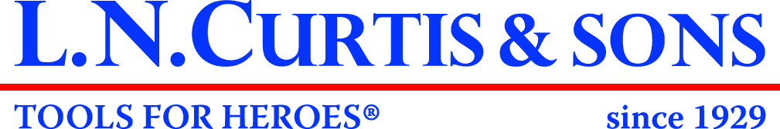

**When: May 17th, 18th, and 19th, 2018**

**Time: Thursday 7:30am-5:00pm**

**Friday, 8:00am-5:30pm**

**Saturday, 8:00am-5:30pm**

**Where: Arvada Fire Training Center**

**6651 Indiana Street, Arvada, CO 80005**

**Cost: $425.00 - Class size limited to 100 students!**

**Class includes: Class Sponsored By:**

* **NFPA 1670 Technician Level training**
* **Heavy focus on hands-on training**
* **Nationally renowned instructors from across the country**
* **Heavy Vehicle Extrication and Stabilization**
* **Lunch, T-Shirt,**
* **New Car Technology to include Hybrids and Airbag Deployments**
* **Vehicle Vendors**

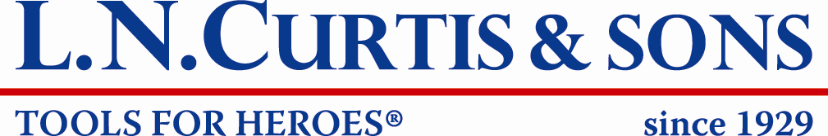







**Connolly’s Towing, Inc.**

**Email Amanda Pollard for a registration form: amanda.pollard@arvadafire.com**