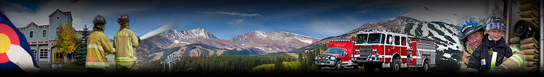

Missouri Valley Division Of Fire Chief’s Conference

Hosted by Red, White & Blue
June 28 - 30th, 2017
Breckenridge, CO

Complete information and registration is open on the R.W & B.

Learn more @ www.RWBFire.org and look for the Missouri Valley Conf. tab or call 970-485-9131.

