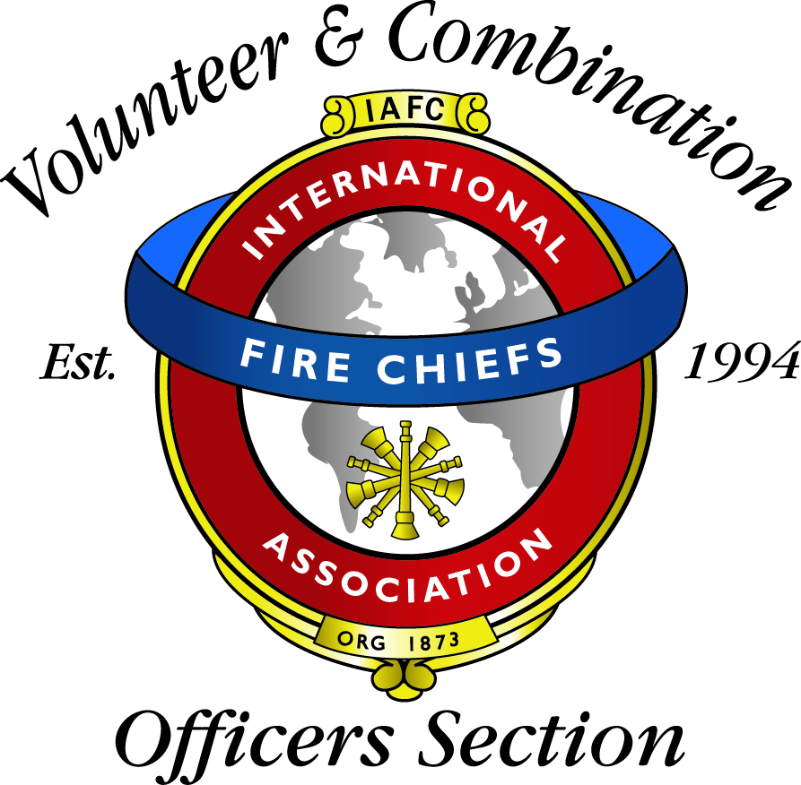
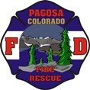
Presents:
Beyond Hoses and Helmets
Leadership for Volunteer & Combination Departments
A course designed for new and existing Fire Officers to enhance their leadership skills.

Pierce Fire Apparatus and the Volunteer and Combination Officers Section (VCOS) of the International Association of Fire Chiefs (IAFC) are pleased to offer an educational training course designed by practicing chief officers that delivers real world expertise through an interactive educational experience. The course is titled “Beyond Hoses and Helmets – Strategy and Tactics of Leading a Volunteer or Combination Fire/Rescue Organization.” The United States Fire Administration and the National Emergency Training Center provided technical support in the development of course material and supporting documents.
The support offered by Pierce Fire Apparatus allows VCOS instructors to present this course throughout the nation in an effort to support the VCOS mission - to provide chief officers who manage volunteers within the fire/rescue/delivery system with information, education, services and representation to enhance their professionalism and capabilities.

“Beyond Hoses and Helmets” offers instruction in the following modules:
- Problem-solving
- Marketing
- Recruitment
- Retention
- Leadership
- Team Building
- Training Development
- Conflict Resolution
- Principles of Negotiation
- Verbal Communications
Presenter: Tom LaBelle
Date: September 8, 2017
Location: Pagosa Fire Protection
To Register, contact: Jasmin Wampler 970-731-4191
jwampler@pagosafire.com

