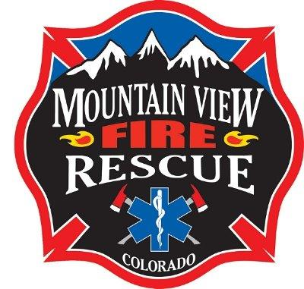

Mountain View Fire Rescue will be hosting an Instructional Methodology class on December 8-9, 2017 from 0830-1700 at MVFR Station 10 located at 9119 E. County Line Road, Longmont, CO 80501.

Ned Sparks, Division Chief with Loveland Fire Rescue Authority, will be facilitating a 16 hour course on the following topics; Role of the Instructor, Safety, Legal Considerations, Psychology of Learning, Public Speaking, and Instructional Delivery. The class meets the training requirements set forth by the Colorado Division of Fire Safety for the Instructor 1 level.

Students are encouraged to read the IFSTA Fire and Emergency Services Instructor text book pertaining to the NFPA 1041 Fire Instructor 1 requirements, prior to class. The student must attend both days to obtain a certificate of completion. This class does not provide a written or practical test for the State of Colorado Fire Instructor 1 certification testing process. The class assist the student preparing for the practical test and provides the opportunity to meet other instructors in the emergency service field.

The fee for the course is $50, with checks payable to Mountain View Fire Rescue. If you have questions or wish to sign up for the class please email Captain Bill Schmanski at bschmanski@mvfpd.org. (The class is filling up quickly and will be limited to 24 students on a first come first serve basis.

