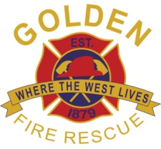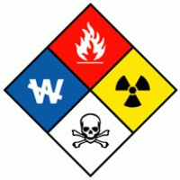

City of Golden Fire Department
2017 Volunteer Recruit Academy
COURSE ANNOUNCEMENT

HAZARDOUS MATERIALS OPERATIONS
3 Weeks/40 Hours

This course will prepare the entry-level firefighter to meet the Colorado State certification requirements for Hazardous Materials Operations. Passing the Colorado State Hazardous Materials written and practical testing is required to obtain your Fire Fighter I state certification.

Reference text: IFSTA Hazardous Materials for First Responders, 4th Edition

CLASS DATES: June 14, 2017 – June 29, 2017

CLASS TIME: Wednesday – Thursday 1800-2200 hours Saturdays 0700-1700 hours

Class Size: Class size is limited to 20 students, 15 students are required for grant funding of books.

Location: City of Golden Fire Department Station 21 at 911 10th Street Golden, CO.

COST: There will be no cost as long as at least 15 students are attending.

Registrations: Contact Captain Jeanette Kehoe at jkehoe@cityofgolden.net or call 303-215-8888 for
more information.

Deadline is: May 1, 2017

