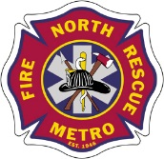
North Metro Fire Rescue District

Is proud to present:

In Honor of the Charleston 9:
A Study of Change Following Tragedy

By: Dr. David Griffin
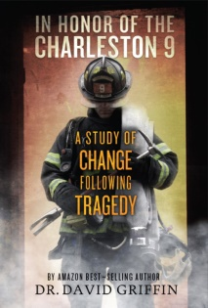

On June 18, 2007, nine firefighters perished in a warehouse fire in Charleston, SC. What was initially dispatched as a trash fire escalated into one of the most scrutinized events in national fire service history. David had the unfortunate experience of being the engineer on the first due engine that day. As he operated on the fireground, he witnessed things that he will never forget.

This seminar will present:
- First-hand accounts of that day.
- Never before seen video footage with radio traffic.
- Initial resistance to the changes following the tragedy.
- The heavy toll that this catastrophic event took on David’s life.
- The incredible changes that he and the CFD have made.
- Scientific research regarding the change process following this event.
- Details from the coinciding Best Selling Book,
In Honor of The Charleston 9: A Study of Change Following Tragedy

When: April 11th 0800-1200 (all three sessions are the same class)
April 11th 1300-1700
April 12th 0800-1200
Cost: $50.00 per student
Location: 1006 Weld County Road 11 – Building C, Northglenn
RSVP Contact: Debbie VanWanseele at 303-252-3502

For additional information please see Dr. Griffin’s “Find your Mission Tour” website: http://www.drdavidgriffin.com/about.html

