When
Friday May 12, 2017 at 7:30 AM MDT
-to-
Sunday May 14, 2017 at 5:30 PM MDT
Add to Calendar

Where
Arvada Fire Training Center
6651 Indiana Street
Arvada, CO 80005
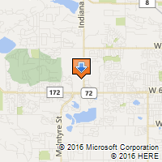
Driving Directions

Contact
Amanda Pollard
Arvada Fire Protection District
303-424-3012
amanda.pollard@arvadafire.com

2017 Arvada Auto X
Class size is limited to 100 students.
Class Includes:
• NFPA 1670 Technician Level training
• Heavy focus on hands-on training
• Nationally renowned instructors from across the country
• Heavy Vehicle Extrication and Stabilization
• Lunch, T-Shirt, Auto X CD Provided
• New Car Technology to include Hybrids and Airbag Deployments
• Vehicle Vendors
Register Now!

