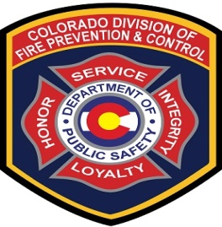 2017 REQUEST FOR HOST 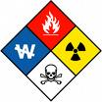ORGANIZATIONS FOR HAZARDOUS MATERIALS TRAINING
Colorado Division of Fire Prevention and Control
All courses must be delivered prior to September 30, 2017

The Colorado Division of Fire Prevention and Control is seeking local emergency response agencies to host a variety of hazardous materials courses throughout the State of Colorado. We are looking to identify host organizations that can also recruit attendees for the following courses:

1. Hazardous Materials Safety Officer (2 days- 16 hours)
2. Hazardous Materials Air Monitoring (2 days- 16 hours)
3. Hazardous Materials Technician (10 days-80 hours)
4. Hazardous Materials Highway Specialist (5 Days – 40 Hours)
5. Introduction to the Computer-Aided Management of Emergency Operations (CAMEO) Suite (3 days – 24 hours)
6. Haz Mat IQ-Chemical Hazard ID Class (1 Day – 8 Hours)
7. Haz Mat Tox Medic IQ Course (1 Day – 8 Hours)

When: Submit this form by November 30, 2016
Email: lisa.pine@state.co.us
Fax: 303-239-5879

Requirements:
- Free use of a classroom and drill ground facility capable of comfortably seating 30 students
- Local sponsor must have at least 12 students enrolled
- Appropriate number of table and chairs to provide classroom seating
- PowerPoint projector and other typical classroom A/V Furnishings

Questions: Direct to: lisa.pine@state.co.us or 303-239-5879

Sponsor:

Organization Name:

Classroom Address:

Contact Name:

Contact Cell Phone:

Requested Course:

Course Dates

(Please list 2 options):

