2017

Volunteer Fire Assistance (VFA)

Grant Scoring Guide

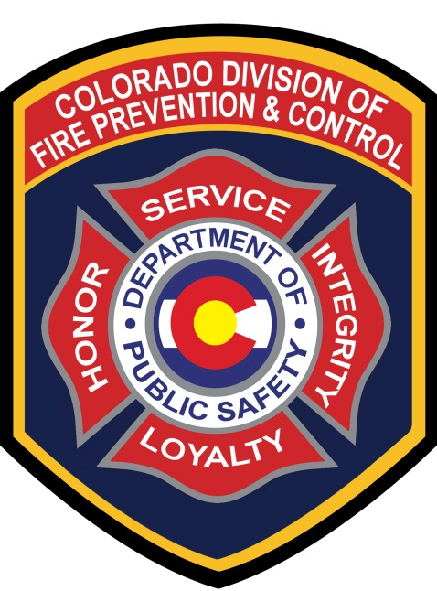

Administered By:

Colorado Division of Fire Prevention and Control

Volunteer Fire Assistance Grant
Application Scoring Guide
Cooperative Fire Protection Program

This guide outlines program eligibility requirements and provides assistance with completing the scoring of Colorado Volunteer Fire Assistance applications.

Purpose of the Volunteer Fire Assistance Program (VFA)
The purpose of the Volunteer Fire Assistance (VFA) Program is to provide Federal financial, technical and other assistance to organize, train and equip rural fire departments in rural communities to prevent and suppress fires.
Program Eligibility includes;
- A single fire department serving a rural area or a rural community with a population of 10,000 or less (the community may be incorporated, unincorporated, a township or some other identifiable descriptor). A single community fire department serving a population greater than 10,000 and not providing protection to a rural area or to a rural community is not eligible for VFA financial assistance.

- A willingness to report wildland fires to State Foresters in the wildland fire module of the National Fire Incident Reporting System (NFIRS). If you are not currently using NFIRS, and need assistance in getting started, please contact your Division of Fire Prevention and Control (DFPC) Regional Fire Management Officer (FMO).

- Availability of Community Share (match) funds. The community share (50% match) of the financial assistance must be available at the time of application.
- As part of the competitive grant process, low Peer review scores may result in denial. Higher scores demonstrate the greatest need, meaning a lower score may indicate;
  - The application is inconsistent with the program’s objectives of protecting property in unprotected or inadequately protected rural areas and wildlands.
  - The application did not demonstrate the greatest need, and/or will not increase the incident responsiveness and Insurance Services Office (ISO) rating of the community.

Fire Department Applicants unable to meet one or more of the above criteria are considered ineligible for the VFA Grant. Proceed to scoring those applications that meet the above criteria.

Grants Scoring Considerations

- Size of community (population).

- Insurance Services Office (ISO) rating for the community, higher scores receive preference.

- Willingness of the community to provide wildfire statistical reports (such as National Fire Incident Reporting System - NFIRS) to the State Forester or DFPC.

- Availability of Community Share (match) funds. The community share (50% match) of the financial assistance must be available at the time of application.

- Preference is given to qualifying fire departments having a membership of at least 80% volunteer firefighters.

- Availability of mutual-aid forces from other communities to provide fire suppression assistance to the community.

- Use(s) of funding (i.e., personal protective equipment (wildland PPE); conversion of Federal Excess Personal Property to fire apparatus; improvement of radio communications capability; installation of dry fire hydrants, cisterns, and other measures to improve water supplies; purchase of water and foam delivery equipment such as portable pumps, hose, foam proportioners, air compressors, foam concentrate, portable water tanks; training of rural firefighters, organizing new fire departments; and fire prevention activities).

- Recent VFA Grants awarded to the community.

- Number of incidents responded to and potential for large-loss fires.

- Amount and condition of the community’s fire equipment.

The scoring matrix is as follows:

Criteria | Total Points allowed
80% Volunteer | Yes = 20 |  | Preference given
Recent VFA Grant Awarded | Never ≥ 3 years | 2015 | 2016 | 2017
 | 20 points | 15 points | 10 points | 5 points
ISO rating | 8-10 | 5-7 | 3-4 | 1-2
Score | 20 points | 15 points | 5 points | 0 points
Five (5) points allowed each category or 20 points total for Criteria
Community Vulnerability | Total Incidents | High Fire District | Mutual Aid received | Mutual Aid Given
Use of Funds | Wildland PPE | FEPP/FPP | Training | 0 non-fire related

