2017

Volunteer Fire Assistance (VFA)

Grant Application Guide

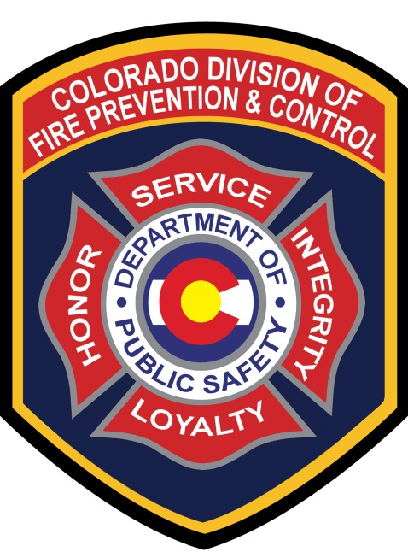

Administered By:

Colorado Division of Fire Prevention and Control

Volunteer Fire Assistance Grant
Application Guide
Cooperative Fire Protection Program

This guide outlines program eligibility requirements and provides assistance with completing the Colorado Volunteer Fire Assistance application.

Purpose of the Volunteer Fire Assistance Program (VFA)
The purpose of the Volunteer Fire Assistance (VFA) Program is to provide Federal financial, technical and other assistance to organize, train and equip rural fire departments in rural communities to prevent and suppress fires.
Program Eligibility includes;
- A single fire department serving a rural area or a rural community with a population of 10,000 or less (the community may be incorporated, unincorporated, a township or some other identifiable descriptor). A single community fire department serving a population greater than 10,000 and not providing protection to a rural area or to a rural community is not eligible for VFA financial assistance.

- A willingness to report wildland fires to State Foresters in the wildland fire module of the National Fire Incident Reporting System (NFIRS). If you are not currently using NFIRS, and need assistance in getting started, please contact your Division of Fire Prevention and Control (DFPC) Regional Fire Management Officer (FMO).

- Availability of Community Share (match) funds. The community share (50% match) of the financial assistance must be available at the time of application.
- As part of the competitive grant process, low Peer review scores may result in denial. Higher scores demonstrate the greatest need, meaning a lower score may indicate;
  - The application is inconsistent with the program’s objectives of protecting property in unprotected or inadequately protected rural areas and wildlands.
  - The application did not demonstrate the greatest need, and/or will not increase the incident responsiveness and Insurance Services Office (ISO) rating of the community.

Administrative Considerations
- While non-volunteer fire departments may participate in the VFA Program, preference will be given to qualifying fire departments having a membership of at least 80% volunteer firefighters.

- Applicants may not derive their share from other sources of Federal assistance. This includes but, is not limited to, Federal Emergency Management Agency, US Fire Administration, US Forest Service, or Bureau of Land Management grant(s).

Guidance for Filling out the Application

Please answer every question and fill in every blank on the application form.
Applications with unanswered questions are incomplete and subject to rejection.

The application has changed this year. The application may be saved at each page break. To save, you just hit the next button, then you may log out and re-enter the application. You may also use the back buttons on the application to make changes. Please print a copy of the application for your records prior to hitting the submit button. You will receive an automatic “THANK YOU” message confirming the Division of Fire Prevention and Control has received your application after you click on the submit button.

- Please review the qualification criteria to confirm your department is eligible and your Community Project is eligible for funding. Also, be sure to check the applications deadline. Applications will not be accepted after the published deadline. If your department needs additional assistance completing the application, please call the DFPC Grants Manager for assistance. Application assistance will not extend the deadline.

- Be sure to fill in the Fire Department’s name and identifying number (FFID). The FFID number may be found on the Division of Fire Prevention and Control Website, under the documents for this announcement. Projects submitted by a group of departments/districts working together on a Community Project may receive special consideration provided the narrative outlines the share provided by each participating entity. If this applies to your project, be sure to list the departments (and their FDID) involved in the project. Projects that do not indicate improvement of the protection capabilities will not be eligible. Group applications may not submit a separate individual department application.

- The project request must list the items you wish to purchase, the cost per item/unit, the quantity and the project total. Do not underestimate the cost of the project; be sure to research the entire cost. Your department is responsible for 50% of the cost.

- The narrative is an important part of the application. Explain how the project request(s) will be utilized and describe the benefit(s) to the department /district/community served. The better the project is explained, the higher the chances of it being funded. Remember, this is not income to supplement a department; it is a competitive grant intended to assist the entire community being served.

- The signatures on the application must include the Fire Chief and the Fire Department financial representative. These signatures are inferred when the grant is validated prior to submission. This ensures the Fire Chief and financial representative knows which projects are being requested, and the financial representative has identified and reserved the 50% match prior to the application being submitted.

Grants Scoring Considerations

- Size of community (population).

- Insurance Services Office (ISO) rating for the community, higher scores receive preference.

- Willingness of the community to provide wildfire statistical reports (such as National Fire Incident Reporting System - NFIRS) to the State Forester or DFPC.

- Availability of Community Share (match) funds. The community share (50% match) of the financial assistance must be available at the time of application.

- Preference is given to qualifying fire departments having a membership of at least 80% volunteer firefighters.

- Availability of mutual-aid forces from other communities to provide fire suppression assistance to the community.

- Use(s) of funding (i.e., personal protective equipment (wildland PPE); conversion of Federal Excess Personal Property to fire apparatus; improvement of radio communications capability; installation of dry fire hydrants, cisterns, and other measures to improve water supplies; purchase of water and foam delivery equipment such as portable pumps, hose, foam proportioners, air compressors, foam concentrate, portable water tanks; training of rural firefighters, organizing new fire departments; and fire prevention activities).

- Recent VFA Grants awarded to the community.

- Number of incidents responded to and potential for large-loss fires.

- Amount and condition of the community’s fire equipment.

