2017

Volunteer Fire Assistance (VFA)

Grant Program Guide

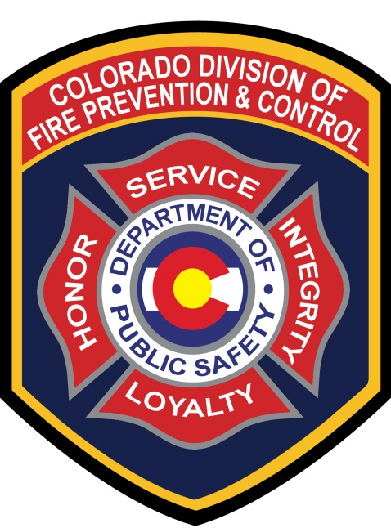

Administered By:

Colorado Division of Fire Prevention and Control

2017 Program and Timeline

April 23, 2018 Announcement letter and application sent to Regional FMOs for distribution to eligible departments.

June 8, 2018 VFA Application Deadline Proposals due to DFPC Grant Manager.

June 11-22, 2018 Peer Review Application Scoring

June 18-21, 2018 Notify applicants of grant award decisions.

June 30, 2018 Please notify the DFPC Grant Manager by this date if you are unable to use your awarded funds.

December 1, 2017- August 2018

All VFA purchases must be made between these dates.

September 30, 2018

All receipts and reimbursement requests must be received by DFPC.
No receipts or reimbursement requests will be accepted after this date.

VFA reimbursement payments will be processed when documentation is complete and reviewed by the VFA Grant Administrator.

Volunteer Fire Assistance Program Guide
Cooperative Fire Protection Program
This guide outlines program eligibility requirements and provides assistance with completing the Colorado Volunteer Fire Assistance application.

Purpose of the Volunteer Fire Assistance Program (VFA)
The purpose of the Volunteer Fire Assistance (VFA) Program is to provide Federal financial, technical and other assistance to organize, train and equip rural fire departments in rural communities to prevent and suppress fires. The funding for the VFA program is passed through the Colorado Department of Public Safety (CDPS), Division of Fire Prevention and Control (DFPC), from the United States Department of Agriculture Forest Service (USDA FS) Rocky Mountain Region, R2 Federal Financial Assistance of Domestic Grants.
Program Eligibility includes;
- A single fire department serving a rural area or a rural community with a population of 10,000 or less (the community may be incorporated, unincorporated, a township or some other identifiable descriptor). A single community fire department serving a population greater than 10,000 and not providing protection to a rural area or to a rural community is not eligible for VFA financial assistance.

- A willingness to report wildland fires to State Foresters in the wildland fire module of the National Fire Incident Reporting System (NFIRS). If you are not currently using NFIRS, and need assistance in getting started, please contact your Division of Fire Prevention and Control (DFPC) Regional Fire Management Officer (FMO).

- Availability of Community Share (match) funds. The community share (50% match) of the financial assistance must be available at the time of application.
- As part of the competitive grant process, low Peer review scores may result in denial. Higher scores demonstrate the greatest need, meaning a lower score may indicate;
  - The application is inconsistent with the program’s objectives of protecting property in unprotected or inadequately protected rural areas and wildlands.
  - The application did not demonstrate the greatest need, and/or will not increase the community’s incident responsiveness and Insurance Services Office (ISO) rating.

Administrative Considerations
- While non-volunteer fire departments may participate in the VFA Program, preference will be given to qualifying fire departments having a membership of at least 80% volunteer firefighters.
- Applicants may not derive their share from other sources of Federal assistance. This includes but, is not limited to, Federal Emergency Management Agency, US Fire Administration, US Forest Service, or Bureau of Land Management grant(s).

- The community share of financial assistance can be in the form of cash or in-kind contributions. Examples of in-kind contributions would be volunteer hours for work done on the project items such as installing a pump or attending a training session (if a volunteer firefighter), donated space for holding a training session and donated labor from a vendor providing one of the items purchased under the grant. Documentation needs to be provided for the in-kind match, including, but not limited to:

Description | Documentation Examples & Description
Volunteer Hours | Training roster sheet that shows: type of training, name of instructor, date, length of time, and list of names, in addition to, a timesheet signed by the instructor.
 | A Department log showing a person’s name, date, time worked and activities performed signed by the Fire Chief.
Donated Supplies | A receipt showing donated item, cost, date and signature of person/vendor making the donation. A donation receipt from the local fire agency would be best.
Donated Professional Time (mechanic, attorney, physician, etc.) | Individual must provide an invoice that shows business name and address stating time donated by dates and hours and activity performed. In addition, the occupational hourly/daily rate for services provided.
Donated Use Time (meeting hall, mechanic shop, etc.) | Individual must provide an invoice that shows business name and address stating time donated by dates, with hours and activity performed. In addition, a time sheet indicating the occupational hourly/daily rate for services provided signed by the Supervisor of record.
All activity must be documented and submitted to DFPC Grants Manager; this is part of the Official Record and must be verified. The In-Kind Match activity cannot be part of the daily operational activity or used as In-Kind Match (double counted) for any other grant. Please submit questions for the DFPC Grants Manager, Darlene Nelson, to: cdps_dfpc_grants@state.co.us.

Program Rules
- VFA grants may be approved to fire training academies for rural fire departments, including those operated by federally recognized Indian tribes. Training recipients must come from fire departments that qualify for VFA funding.

- VFA purchases must be fire related. Medical gear or equipment may not be purchased.

- Applications for funding to convert Federal Excess Personal Property (FEPP)/ Forest Fire Prevention (FFP) equipment to water tenders, engines, brush trucks, and equipment trucks are encouraged. The purchase of wildfire or urban interface apparatus, tools and appliances is encouraged. Prohibited items include tires, oil, replacement parts, etc.

- Equipment and supplies which may be purchased under the program include, but are not limited to, radios (narrowband VHF), various nozzles and hoses, hand tools, personal protective clothing (wildland), portable pumps and generators, class “A” foam delivery equipment and foam concentrate.

- Rural wildland fire training materials and classes may be purchased utilizing VFA funds, including computers.

- Currently, no single award will exceed $10,000.00. A single item may not be more than $4,999.00.

- VFA funding is not authorized for the purchase, construction, or renovation of capital improvements. This includes, but is not limited to, building or improving fire stations and pressurized water systems.

VFA program guidelines and eligibility questions should be directed to the Grants Manager, Darlene Nelson at (303) 239-5868 or via email at cdps_dfpc_grants@state.co.us.

VFA exists to increase the department’s ability to respond to wildland fire, and to cooperate and communicate with federal wildland fire agencies. Therefore, equipment and training that support wildland fire response, cooperation and communication with federal agencies will be the priority.
- Many items can be covered under the grant program. Higher priority purchases will include:
  - Wildland fire personal protective equipment (PPE)
  - Wildland fire tools, hose, etc.
  - Narrowband VHF radios
  - Wildland fire training

- Examples of items commonly requested, but not eligible for reimbursement and will not be considered for funding, are:
  - Self-contained breathing apparatus (SCBA)
  - Structural PPE, including bunker gear and structural fire helmets
  - 800 MHz trunking radios or other UHF radios
  - EMS, all-hazard or other training not directly applicable to wildland fire
  - Boots

